**LAB 5**

**AIM: Implement the following algorithms**

**1. Take 'pout.tif' image and perform Gray-level Slicing on it. Diplay images with**

**2, 16, 64, 128 and 256 graylevels.**

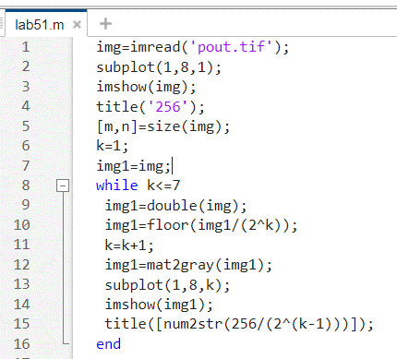

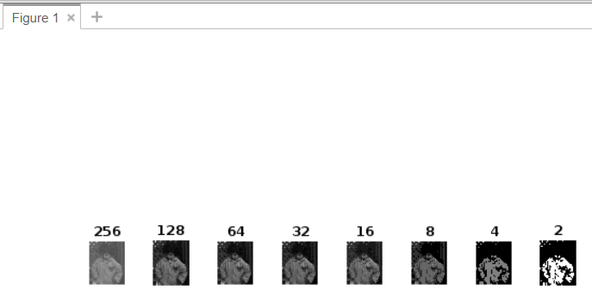

**2. Consider an image of 128x128 (Hint: You can resize 'cameraman.tif' to 0.5)**

**and Implement Nearest-Neighbour Interpolation Algorithm and covert into**

**256x256. Don't use in-buit functions like linspace, meshgrid and interp2.**

**Compare your result with the result obtained using the function interp2.**

**3. Take 'Cameraman.tif' image and implement Shear Transformation.**

**a. Apply shear transformation in X-direction with value 2**

**b. Apply shear transformation in Y-Direction with value 3**

**c. Compare your result with the output generated by in-built function**

**imtransform.**